TMD Friction celebrates 100 years of Bendix
TMD Friction is celebrating the 100th birthday of its aftermarket braking brand Bendix. Now manufactured and distributed by TMD Friction in 17 countries, Bendix offers high-quality braking products in the aftermarket for all car parc requirements, today and tomorrow.

LEVERKUSEN, 16 April 2024 Braking brand Bendix is turning 100. The brand was founded in 1924 by Vincent Bendix to supply mechanical brake shoes for General Motors. It was the first company to sell drum brake shoes, and later, became the first company to sell brake shoe kits. Today, the Bendix product portfolio includes brake pads, brake discs, ABS sensors, brake shoes, brake shoe kits, wear indicators, and brake drums and covers 98 per cent of the European car parc.

TMD Friction, a leading manufacturer of brake friction products with more than 140 years of experience, has been manufacturing and distributing Bendix products since 2021.
Today, TMD Friction sells Bendix passenger car and light commercial vehicle products in 17 countries in Europe, the Middle East and Africa, with the most recent expansion taking place in Poland earlier this year.

Clément de Valon, Executive Vice President Independent Aftermarket at TMD Friction says: “We at TMD Friction are honoured to have the opportunity to shape the latest chapter in Bendix history, a brand with a rich heritage stretching back 100 years. Since 2021, we have leveraged our 140 years of expertise to successfully enhance our Bendix products and improve the perception of the brand. Bendix products carry a long history of success, and with our manufacturing and innovation expertise, we will also ensure they are fit for the future.”

Braking excellence since 1924

Vincent Bendix was an eccentric inventor with a talent for things mechanical and a keen mind for business. Born in Moline, Illinois in 1881, he started out manufacturing bicycle brakes, starter drives, and fire engines before partnering up with French engineer Henri Perrot to shift his focus to automotive brakes. With the ingenuity of Perrot – the man who invented the shoe brake – and Bendix’ business sense, the unlikely pair developed the first fully reliable four-wheel brake systems on American cars. Bendix Corporation went public in 1924. The following years saw massive growth as the company raced to keep up with the growing demand for automotive brakes, and in 1928, a fateful partnership with General Motors catapulted it to further success.

By 1929, Vincent Bendix had an estimated net worth of $50 million. The effects of the Great Depression, however, paired with his extravagant lifestyle caused him to go bankrupt by 1939. Nevertheless, his company made a dramatic post-war recovery, and over the next 100 years, Bendix became synonymous for excellence in engineering. The company introduced a range of innovations for passenger cars, commercial vehicles, and aviation applications. Some of the key milestones in the company’s history include the development and mass production of vacuums servos and expansion into hydraulic brakes and fixed-caliper disc brakes. Bendix even built equipment that was used to conduct tests on the surface of the moon.

Over the coming weeks, key milestones from Bendix’ history will be published in series of social media posts on the Bendix Braking International Facebook and Bendix Braking International Instagram pages. Follow the pages to learn more!

How TMD Friction has evolved the Bendix brand

Since joining TMD Friction’s portfolio of aftermarket brands in 2021, Bendix has benefited from the company’s extensive friction manufacturing expertise. A leading brake friction product supplier with more than 140 years of experience, TMD Friction boasts a global Research & Development network with locations in Germany, the UK, Brazil, and China. The company has its own test tracks and fleets to ensure its products offer excellent performance, safety, and comfort. In addition, a dedicated NVH team focuses specifically on maximising braking comfort for electric vehicles, ensuring the company is fit for the future.

This year, to celebrate 100 years of Bendix history, TMD Friction redesigned its Bendix home page, developed new marketing motifs with a new slogan, and gave the brand an updated look and feel. The “Absolute Braking” campaign, which takes front and center on the brand’s new home page, reflects the Bendix brand is about: absolute safety when it really counts. By manufacturing braking products to the highest standards, TMD Friction ensures consumers can trust Bendix brakes one hundred per cent, even in emergency driving situations. By leveraging its extensive manufacturing experience as well as R&D expertise, TMD Friction has successfully ensured the highest quality standards for Bendix products and has improved Bendix’ standing in the aftermarket.

Bendix: a workshop’s trusted partner

One of the Bendix’ key achievements was the invention of brake shoe kits, a true game changer for garages. Brake shoe kits offer more convenience and save time by providing all parts together in one place. It also encourages garages to use all new parts, as part of best practice which ensures proper installation to minimise the risk of returns.

That’s not all Bendix is doing to support garages. The company also offers technical services via a dedicated team of technical trainers to meet the demands of the regions. The trainers can offer best practice advice, in-depth technical training, advice on how to get the best out of each product, and dedicated training on specific parts. In addition, they represent a dedicated point of contact for any questions or requirements the customer has.

Bendix today

Today, Bendix is synonymous with high-quality braking for all car parc requirements, today and in the future. TMD Friction offers 98 per cent car parc coverage with Bendix products in the European aftermarket, providing excellent vehicle coverage to small city cars all the way to light commercial vehicles, hybrids, and EVs.
The Bendix product portfolio includes 1,400 brake pad references and 1,300 brake disc references. In addition, Bendix offers brake drums (184 references), brake shoes (300 references), brake shoe kits (180 references), ABS sensors (450 references) and wear indicators (280 references). Finding the right part quickly is made easy by the Bendix Brakebook app and online catalogue. All products come with the necessary hardware for installation.

Every friction product is in line with strict environmental and regulatory standards. In fact, Bendix products are tested not just to comply with, but to exceed ECE-R90 requirements. Ninety-nine per cent of Bendix friction formulations are copper- and antimony-free.
To learn more, visit the Bendix home page or Bendix brakebook:
Home page: Bendix - Just Got Better (bendix-braking.com)
Brake book: Bendix Brakebook - Your personal online catalogue and marketing service. (bendix-braking.com)

Pictures:
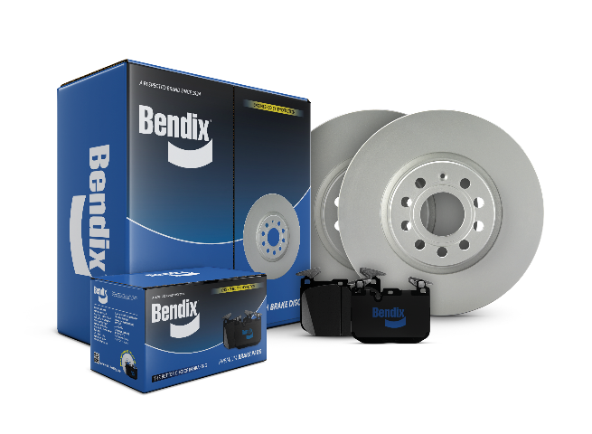
Bendix_ProductComposing_DiscPad.png: TMD Friction is celebrating 100 years of Bendix braking products. With products available for 98 per cent of cars in Europe, the brand offers high-quality braking products for all car parc requirements, today and tomorrow

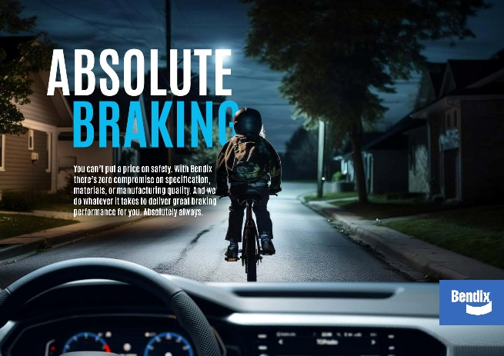
Bendix_ADV_AbsoluteBraking_297x210mm_Bike_WEB.jpeg: The “Absolute Braking” campaign reflects what the Bendix brand is about: absolute safety when it really counts. By manufacturing braking products to the highest standards, TMD Friction ensures consumers can trust Bendix brakes one hundred per cent, even in emergency driving situations.

About TMD Friction

TMD Friction is a leading global supplier of high-quality brake friction solutions to the automotive and brake industries. The company develops and manufactures disc brake pads and drum brake linings for passenger cars and commercial vehicles.

TMD Friction supplies vehicle manufacturers with premium products for original equipment, as well as being a driving force in the international aftermarket with the brands Textar, Mintex, Don, Pagid, Cobreq and Bendix. The product portfolio also includes brake friction products for motor racing under the Pagid Racing and Mintex Racing brands and for industry applications under the Cosid brand.

TMD Friction Group employs more than 4,200 people worldwide with locations across Europe, the Middle East, the USA, Brazil, Mexico, China and Japan.

Contact:
Alison Haywood
PR & Social Media Manager

TMD Friction Holdings GmbH
Schlebuscher Str. 99
51381 Leverkusen

T +49 (2171) 9113-7512
E alison.haywood@tmdfriction.com

